**Class:** Final Year (Computer Science and Engineering)

**Year:** 2022-23 **Semester:** 1

**Course:** High Performance Computing Lab

**Practical No. 8**

**Exam Seat No: 2019BTECS00064**

**Name – Kunal Santosh Kadam**

**Problem Statement 1:**

Study and implement 2D Convolution using MPI. Use different number of processes and analyze the performance.

**Screenshot #:**

**Information #:**

**Problem Statement 2:**

Implement dot product using MPI. Use different number of processes and analyze the performance.

**Screenshot #:**

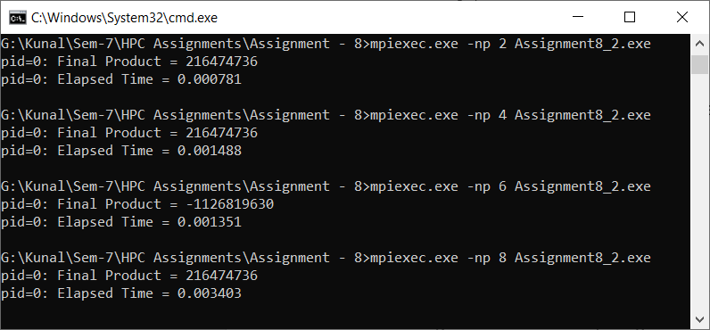

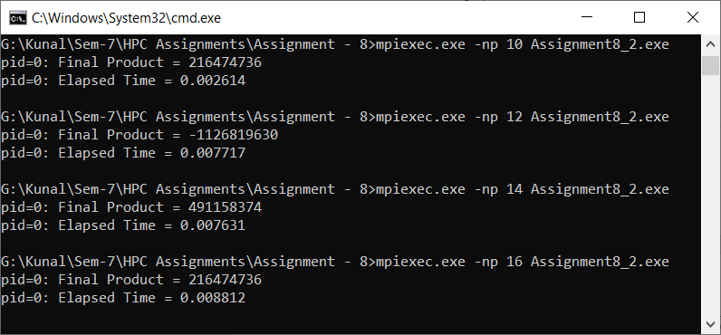

|  |  |
| --- | --- |
| **Processors (Size 100000)** | **Execution Time (sec)** |
| 2 | 0.000781 |
| 4 | 0.001488 |
| 6 | 0.001351 |
| 8 | 0.003403 |
| 10 | 0.002614 |
| 12 | 0.007717 |
| 14 | 0.007631 |
| 16 | 0.008812 |

**Information #:**

#include <stdio.h>

#include <mpi.h>

#include <unistd.h>

#include <math.h>

#include <time.h>

#include <stdlib.h>

#define NELMS 100000

#define MASTER 0

#define MAXPROCS 16

int dot_product();

void init_lst();

void print_lst();

int main()

{

int i,n,vector_x[NELMS],vector_y[NELMS];

int prod,sidx,eidx,size;

int pid,nprocs, rank;

double stime,etime;

MPI_Status status;

MPI_Comm world;

n = 100000;

if (n > NELMS)

{

printf("n=%d > N=%d\n",n,NELMS);

return 0;

}

MPI_Init(NULL, NULL);

world = MPI_COMM_WORLD;

MPI_Comm_size(MPI_COMM_WORLD, &nprocs);

MPI_Comm_rank(MPI_COMM_WORLD, &pid);

int portion = n / nprocs;

sidx = pid * portion;

eidx = sidx + portion;

init_lst(vector_x, n);

init_lst(vector_y, n);

int tmp_prod[nprocs];

for (i = 0; i < nprocs; i++)

tmp_prod[i] = 0;

stime = MPI_Wtime();

if (pid == MASTER)

{

prod = dot_product(sidx, eidx, vector_x, vector_y, n);

for (i = 1; i < nprocs; i++)

MPI_Recv(&tmp_prod[i-1], 1, MPI_INT, i, 123, MPI_COMM_WORLD, &status);

}

else

{

prod = dot_product(sidx, eidx, vector_x, vector_y, n);

MPI_Send(&prod, 1, MPI_INT, MASTER, 123, MPI_COMM_WORLD);

}

if (pid == MASTER)

{

for (i = 0; i < nprocs; i++)

prod += tmp_prod[i];

}

etime = MPI_Wtime();

if (pid == MASTER)

{

//print_lst(vector_x,n);

//print_lst(vector_y,n);

printf("pid=%d: Final Product = %d\n",pid,prod);

printf("pid=%d: Elapsed Time = %f\n",pid,etime-stime);

}

MPI_Finalize();

}

int dot_product(int s,int e, int x[], int y[], int n)

{

int i,prod=0;

for (i = s; i < e; i++)

prod = prod + x[i] * y[i];

return prod;

}

void init_lst(int *l,int n)

{

int i;

for (i=0; i<n; i++)

*l++ = i;

}

void print_lst(int l[],int n)

{

int i;

for (i=0; i<n; i++)

printf("%d ", l[i]);

printf("\n");

}

**Problem Statement 3:**

Implement Prefix sum using MPI. Use different number of processes and analyze the performance.

**Screenshot #:**

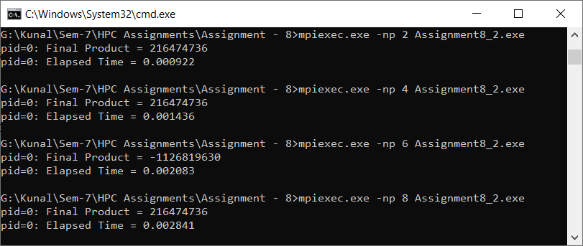

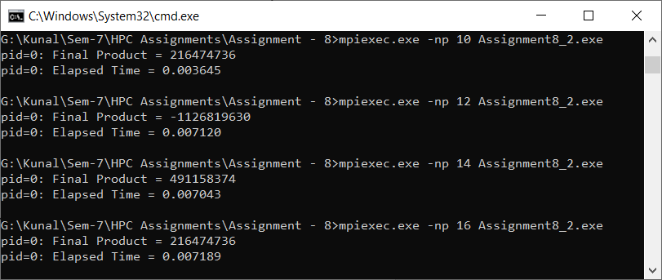

|  |  |
| --- | --- |
| **Processors** | **Execution Time (sec)** |
| 2 | 0.000922 |
| 4 | 0.001436 |
| 6 | 0.002083 |
| 8 | 0.002841 |
| 10 | 0.003645 |
| 12 | 0.00712 |
| 14 | 0.007043 |
| 16 | 0.007189 |

**Information #:**

#include <stdio.h>

#include<stdlib.h>

#include <math.h>

#include <mpi.h>

int main(int argc, char* argv[])

{

int my_rank; /* rank of process */

int p; /* number of processes */

MPI_Status status ; /* return status for receive */

int value;

/* start up MPI */

MPI_Init(&argc, &argv);

/* find out process rank */

MPI_Comm_rank(MPI_COMM_WORLD, &my_rank);

/* find out number of processes */

MPI_Comm_size(MPI_COMM_WORLD, &p);

int prefix_arr[p];

/* getting input and scatter values */

if(my_rank == 0)

{

int i;

for(i = 0; i < p; ++i)

prefix_arr[i] = i + 1;

}

double start = MPI_Wtime();

//all call scatter

MPI_Scatter(prefix_arr, 1, MPI_INT, &value, 1, MPI_INT, 0, MPI_COMM_WORLD);

/*

prefix sum:

repeat log n times

each time, if we are the chosen one, we receve a value from someone and add to ours

otherwise, we send to the chosen one

*/

int i;

int logn = log2(p);

for(i = 0; i <= logn; i++)

{

int lower_bound = pow(2,i);

int upper_bound = p - lower_bound;

if(upper_bound < lower_bound)

upper_bound = lower_bound;

if(my_rank < lower_bound)

{

int send = (int) (my_rank + pow(2,i));

if(send >= p)

continue;

// printf("%d sending to %d\n", my_rank, (int) (my_rank+pow(2,i)));

MPI_Send(&value, 1, MPI_INT, (int) (my_rank+pow(2,i)), 0, MPI_COMM_WORLD);

}

else if(my_rank >= upper_bound)

{

int recv = (int) (my_rank - pow(2,i));

if(recv >= p)

continue;

int recv_value;

// printf("%d receving..\n", my_rank);

MPI_Recv(&recv_value, 1, MPI_INT, (my_rank - pow(2,i)), 0, MPI_COMM_WORLD, &status);

value += recv_value;

}

else

{

int send = (int) (my_rank + pow(2,i));

int recv = (int) (my_rank - pow(2,i));

if(send >= p || recv >= p)

continue;

// printf("%d sending to %d\n", my_rank, (int) (my_rank+pow(2,i)));

MPI_Send(&value, 1, MPI_INT, (int) (my_rank+pow(2,i)), 0, MPI_COMM_WORLD);

// printf("%d receving..\n", my_rank);

int recv_value;

MPI_Status status;

MPI_Recv(&recv_value, 1, MPI_INT, (my_rank - pow(2,i)), 0, MPI_COMM_WORLD, &status);

value += recv_value;

}

}

//after algorithm, each processor hols its own prefix sum

//we gather at rank

int gather[p];

MPI_Gather(&value, 1, MPI_INT, gather, 1, MPI_INT, 0, MPI_COMM_WORLD);

if(my_rank == 0)

{

double end = MPI_Wtime();

printf("\nPerfix Sum Execution Time: %f\n", end - start);

}

/* shut down MPI */

MPI_Finalize();

return 0;

}

**GitHub Link:**